Trevor McLaurine

6/8/2023

Assignment 3.2

**NodeSecurity ORD and JSON**

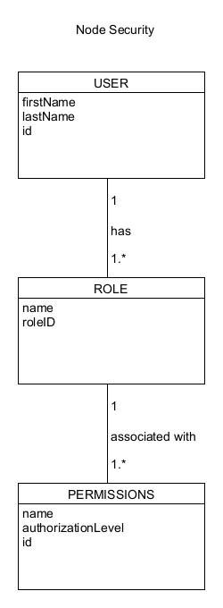

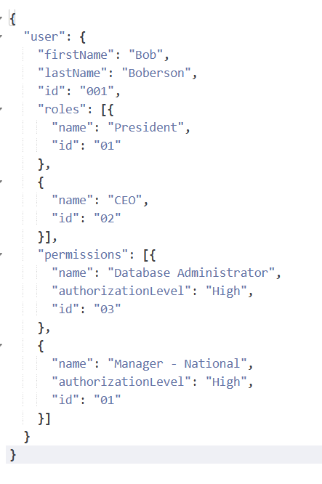

**NodeBookCo ORD and JSON**

